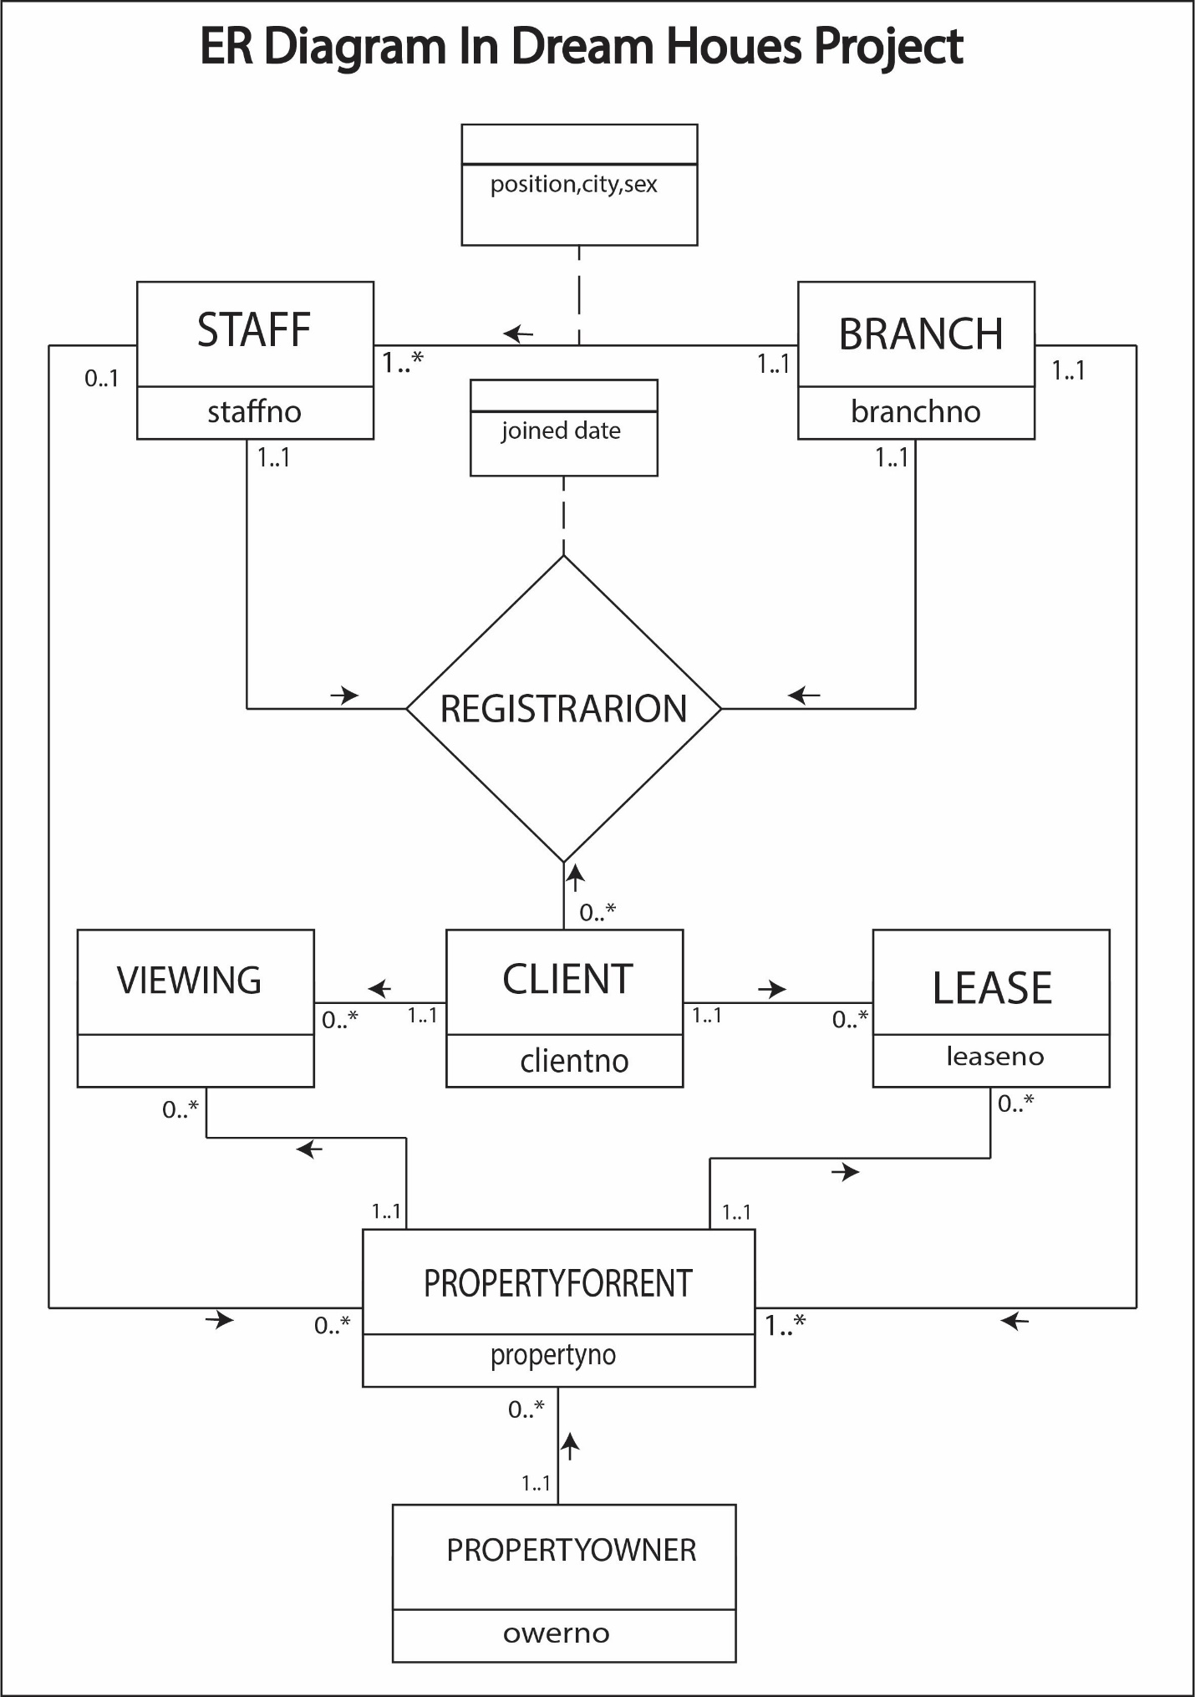

In above ER diagram of dream house case & study project.

* The first table is **branch** and second table is **staff**.
* Primary key of branch is branch no and of staff is staff no.
* Primary key for of branch (branch no) is foreign key of staff as it relates branch to staff.
* Their relation is binary relation which is represented by solid line.
* The direction of tables is branch to staff and their relational attributes are position, city and sex.
* These attribute are represented by dotted line.
* It is mandatory for branch to have at least one staff (one to one ratio) and there is also an option of many staff ad. (one to many ratio)
* The next table **client.** Its primary key is client no.
* There is another table named as **registration** which is represented by diagonal. It is also called relational table as it has no primary key.
* All the primary key of branch, staff, client act as foreign key in registration and direction of all table is toward registration table. Registration table is ternary relation.
* Its relation attribute is joining date.
* Cardinology of registration is
* For branch
* 1to 0
* 1to Many
* For staff
* 1 to 0
* 1 to many
* For client
* 1 to 0
* 1 to many
* **Privteowner** is another table. Its primary key is Owner no and has no foreign key.
* There is a table **Property for rent** whose primary key is property no,
* Branch no, staff no, owner no are foreign keys of property for rent table.
* Direction of all foreign key is towards property for rent.
* The cardinology of property for rent
* For branch to property for rent is
* 1 to 1
* 1 to many
* For staff to property for rent is.
  + 1 to 0
  + 1 to many
* For staff to property for rent is.
* 1 to 1
* 1 to many
* Another table is **view**.
* It has no primary key. Client no, property no, are act as foreign key.
* Their direction is towards view
* Cardinology of view
* For client no
* 1 to 0
  + 1 to many
* For property no
* 1to 0
* 1 to many
* Next table is **lease**
* Its primary key is lease no
* Property no and client no are foreign keys
* Their direction is towards lease
* Cardiology of lease
* For client no
* 1 to 0
* 1 to many
* For property no
  + 1 to 0
* 1 to many